Practical-5
Problem Definition:
Develop bipartite networks using affiliation-based datasets and transform them into one-mode projections for further analysis.
- Create a bipartite graph from the provided dataset.
- Generate one-mode projected networks.
- Calculate and compare important network statistics and measures.

MANDATORY SUBMISSION REQUIREMENTS
Student ID Verification:
- In Code: Declare your Student ID (Enrollment Number) and Full Name as variables and header comments at the very top of your Python script (e.g., STUDENT_ID = "23CS001").
- In Console Output: Print your Student ID and Name at the start of execution so it appears at the top of all terminal output (print(f"Student ID: {STUDENT_ID}")).
- In Plot Titles: Display your Student ID in the main title of all generated network plots, charts, and visualizations (e.g., plt.title(f"Network Graph - {STUDENT_ID}")).
Screenshots Required: You must include clear screenshots showing:
- Terminal/Console Output displaying your printed Student ID and execution results.
- Visualization Graphs & Plots showing your Student ID rendered directly in the graph title.
Note: Submissions without the Student ID clearly visible in the source code, execution logs, and graph titles will not be evaluated.
___________________________________________________________________________
Tools required:
- Dataset: DBLP / MovieLens Dataset
- Libraries: Python, NetworkX, Matplotlib

Source Code

(Paste Python Code Here (Bipartite Graph Building & One-Mode Projection)
# ==================================================================
# STUDENT_ID = "23CE115"
# STUDENT_NAME = "Priya Pedhadiya"
# ==================================================================
STUDENT_ID = "23CE115" # Updated with your actual Student ID
STUDENT_NAME = "Priya Pedhadiya" # Updated with your actual Name
# Console Output Verification
print("="*50)
print(f"Student ID: {STUDENT_ID}")
print(f"Student Name: {STUDENT_NAME}")
print("Practical-5: Bipartite Networks & One-Mode Projections")
print("="*50)
import networkx as nx
import matplotlib.pyplot as plt
from networkx.algorithms import bipartite
import pandas as pd
# --- 1. Create a Bipartite Graph (Simulating MovieLens User-Movie Ratings) ---
B = nx.Graph()
# Define the two node sets
users = ['User1', 'User2', 'User3', 'User4', 'User5']
movies = ['MovieA', 'MovieB', 'MovieC', 'MovieD', 'MovieE']
B.add_nodes_from(users, bipartite=0) # Set 0 for Users
B.add_nodes_from(movies, bipartite=1) # Set 1 for Movies
# Add user-movie rating links (edges)
edges = [
('User1', 'MovieA'), ('User1', 'MovieB'), ('User1', 'MovieC'),
('User2', 'MovieB'), ('User2', 'MovieD'),
('User3', 'MovieA'), ('User3', 'MovieC'), ('User3', 'MovieE'),
('User4', 'MovieD'), ('User4', 'MovieE'),
('User5', 'MovieA'), ('User5', 'MovieD')
]
B.add_edges_from(edges)
# Verify if the graph is bipartite
is_bip = bipartite.is_bipartite(B)
print(f"Is the constructed graph bipartite? {is_bip}\n")
# --- 2. Generate One-Mode Projected Networks ---
# Projected Graph for Node Set A (Users)
user_projection = bipartite.projected_graph(B, users)
# Projected Graph for Node Set B (Movies)
movie_projection = bipartite.projected_graph(B, movies)
# --- 3. Calculate Network Statistics & Measures ---
def calculate_metrics(G, is_bipartite_graph=False):
metrics = {}
metrics['Total Nodes'] = G.number_of_nodes()
metrics['Total Edges'] = G.number_of_edges()
# Average Degree
degrees = [d for n, d in G.degree()]
metrics['Average Degree'] = sum(degrees) / len(degrees) if len(degrees) > 0 else 0
# Clustering Coefficient
if is_bipartite_graph:
# Standard clustering coefficient is 0 for bipartite graphs,
# but networkx has a specific bipartite clustering coefficient
bc = bipartite.clustering(G)
metrics['Clustering Coefficient'] = sum(bc.values()) / len(bc) if len(bc) > 0 else 0
else:
metrics['Clustering Coefficient'] = nx.average_clustering(G)
return metrics
bip_metrics = calculate_metrics(B, is_bipartite_graph=True)
user_metrics = calculate_metrics(user_projection)
movie_metrics = calculate_metrics(movie_projection)
# Create Comparison Table
data = {
'Network Property': ['Total Nodes', 'Total Edges', 'Average Degree', 'Clustering Coefficient'],
'Original Bipartite Graph': [
bip_metrics['Total Nodes'],
bip_metrics['Total Edges'],
round(bip_metrics['Average Degree'], 3),
round(bip_metrics['Clustering Coefficient'], 3)
],
'Projected Graph (Users)': [
user_metrics['Total Nodes'],
user_metrics['Total Edges'],
round(user_metrics['Average Degree'], 3),
round(user_metrics['Clustering Coefficient'], 3)
],
'Projected Graph (Movies)': [
movie_metrics['Total Nodes'],
movie_metrics['Total Edges'],
round(movie_metrics['Average Degree'], 3),
round(movie_metrics['Clustering Coefficient'], 3)
]
}
df_comparison = pd.DataFrame(data)
print("--- Metric Comparison Table ---")
display(df_comparison)
print("\n")
# --- 4. Visualizations with Student ID in Titles (Plotted Separately) ---
# Plot 1: Bipartite Graph
plt.figure(figsize=(8, 6))
pos = {}
pos.update((node, (1, index)) for index, node in enumerate(users))
pos.update((node, (2, index)) for index, node in enumerate(movies))
nx.draw_networkx_nodes(B, pos, nodelist=users, node_color='skyblue', node_size=600, label='Users')
nx.draw_networkx_nodes(B, pos, nodelist=movies, node_color='orange', node_size=600, label='Movies')
nx.draw_networkx_edges(B, pos, width=1.5, edge_color='gray')
nx.draw_networkx_labels(B, pos, font_size=10, font_weight='bold')
plt.title(f"Bipartite Graph - {STUDENT_ID}", fontsize=14, fontweight='bold')
plt.axis('off')
plt.legend()
plt.tight_layout()
plt.show()
# Plot 2: User One-Mode Projection
plt.figure(figsize=(8, 6))
pos_user = nx.circular_layout(user_projection)
nx.draw(user_projection, pos_user, with_labels=True, node_color='skyblue', node_size=800, font_weight='bold', edge_color='blue')
plt.title(f"User Projection Graph - {STUDENT_ID}", fontsize=14, fontweight='bold')
plt.tight_layout()
plt.show()
# Plot 3: Movie One-Mode Projection
plt.figure(figsize=(8, 6))
pos_movie = nx.circular_layout(movie_projection)
nx.draw(movie_projection, pos_movie, with_labels=True, node_color='orange', node_size=800, font_weight='bold', edge_color='darkorange')
plt.title(f"Movie Projection Graph - {STUDENT_ID}", fontsize=14, fontweight='bold')
plt.tight_layout()
plt.show()

Execution Results & Metric Comparison
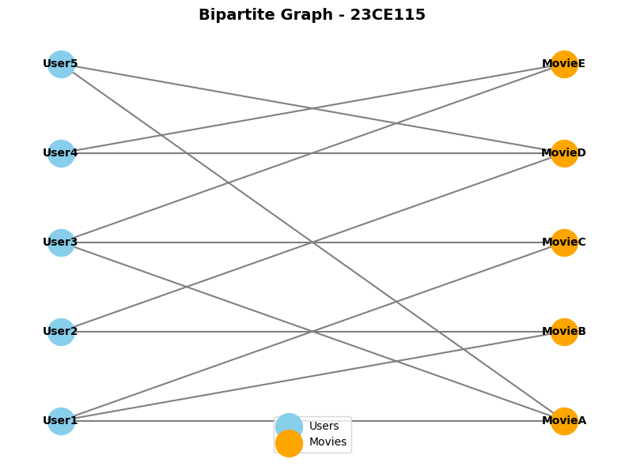
- Bipartite Network Graph Plot: (Paste plot showing two distinct sets of nodes)

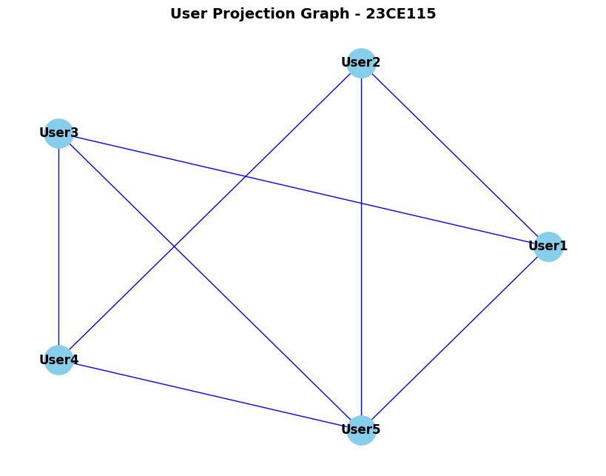
- One-Mode Projected Network Graph Plot: (Paste projected user/item node graph)

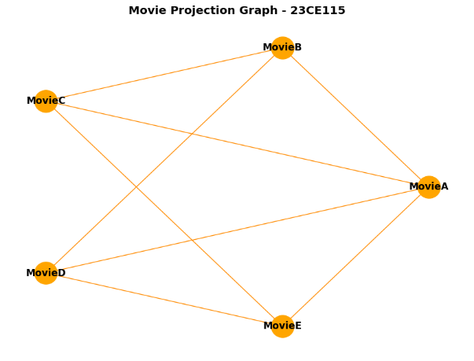
Metric Comparison Table:
Network Property | Original Bipartite Graph | Projected Graph (Node Set A) | Projected Graph (Node Set B)
Total Nodes | 10.000 | 5.000 | 5.000
Total Edges | 12.000 | 8.000 | 8.000
Average Degree | 2.400 | 3.200 | 3.200
Clustering Coefficient | 0.314 | 0.667 | 0.667

Key Questions & Data Interpretation
- What insights does the projected graph reveal compare to the bipartite graph?
  - Answer: The bipartite network only reveals direct, explicit interactions (e.g., which user watched which movie), but completely hides the intrinsic relationships within the same group of entities.
    - The User-Mode Projection reveals implicit communities and groups of similar users who share common item preferences. This helps us find groups of people with identical tastes.
    - The Movie-Mode Projection uncovers latent associations among content, showing which movies are frequently consumed together. This helps identify clusters of complementary items.

- What structural differences are observed in network statistics after projection?
  - Answer:
    - Node Population: The total number of nodes drops from 10 in the original bipartite structure to 5 in each individual projection, focusing strictly on a single entity type.
    - Network Density and Average Degree: The average degree increases from 2.400 to 3.200, because multi-step relationships via common neighbors collapse into direct edges.
    - Clustering Coefficient: Bipartite graphs have no odd-numbered cycles (meaning zero standard triangles). Upon projection, these common affiliations create highly dense local structures, increasing the clustering coefficient from 0.314 (bipartite metric) to 0.667.

Learning Outcomes
(Summarize practical applications in recommendation systems and affiliation network analysis)

Affiliation and Co-occurrence Analysis: Mastered the methodology to transform indirect affiliation structures into explicit one-mode networks to focus on specific entity interactions.

Recommender Systems: Understood how bipartite projections serve as the absolute mathematical foundation for Collaborative Filtering models (both User-based and Item-based approaches) used in industry-scale recommendations.

